*Florida International University*

*School of Computing and Information Sciences*

CIS 4911 - Senior Capstone Project

Software Engineering Focus

Feature Document

User Story #1013

**Team Member: Vladan Lalovic**

**Product Owner(s)**: Mohsen Taheri

**Mentor(s)**: Mohsen Taheri

**Instructor**: Masoud Sadjadi

**User Story** - Update Login Specifications

**Description - (#1)** As a Developer, I want to make sure that when Users login to the site, they are redirected to the Home Page, not to their Profile page, so that they may immediately begin using the site.

**(#2)** As a Developer, I want to make sure that Guests who attempt to access the “Project Proposals Page” or “Student Application Page” are automatically redirected to the Login page. Then, if the Guest decides to Login, they will automatically be redirected back (either to the “Project Proposals Page” or “Student Application Page”). This ensures smooth functionality of the website.

**Acceptance Criteria**

1. Users are redirected to the Home Page after a Successful Login.
2. Guests are redirected to the Login Page when attempting to access the “Project Proposals Page”.
3. Guests are redirected to the Login Page when attempting to access the “Student Application Page”.
4. Guests who were redirected to the Login Page via the “Project Proposals Page” or “Student Application Page” are automatically redirected BACK to those pages if they Successfully Login.

**Use Case - Update the Login Page according to Specifications**

**Use Case ID:** (VIP-1013)

**Details:** Testing and updating the Login script, so that it redirects the user to the home page after a successful login. Securing the “Project Proposals Page” and “Student Application Page” so that only certain User Types can access these pages. Implementation of an auto-redirect back to the “Project Proposals Page” and “Student Application Page”, after a guest has successfully logged in.

**Actor:** Developer

**Pre-conditions:**

1. Developer logs into all 3 types of user accounts (Student, Faculty/Staff, and Pi/CoPi) to test the Profile Page features.
2. The accounts being used to perform the tests have been previously verified and approved via email.
3. Developer has navigated to the “Profile Page” (<http://vip.fiu.edu/#/profile)>.

**Description:**

1. Use case begins when the Developer navigates to the “Profile Page” (http://vip.fiu.edu/#/profile).
2. Developer will change his/her “User Type” and/or “Rank” to a different value using the respective drop-down menus.
3. Developer will click on the “Update” button at the bottom of the page to confirm the changes.

**Post-conditions:**

1. The “Profile Page” will refresh and display 1 of 2 possible messages that indicate success.

* The message “Profile Updated. Waiting for PI Approval.” Indicates that the user needs permission from a Pi/CoPi to update their userType.
* The message “Profile Updated.” Means that all requested profile changes have been performed, and no Pi/CoPi approval is required.

1. If required, an email will automatically be sent to the Pi/CoPi that the User is attempting to Update his/her profile.
2. The Users profile will remain the same until the PI has approved the changes.

**Alternative Courses of Action:**

N/A

**Exceptions:**

N/A

**Related Uses Case:**

1. Login
2. Nodeemailer

**Modification History:**

**Owner:** Vladan Lalovic

**Initiation date:** 5/28/2016

**Date last modified:** 6/20/2016

**Unit Test & Integration Test**

**Visual User Guide**

1. **Login to website**

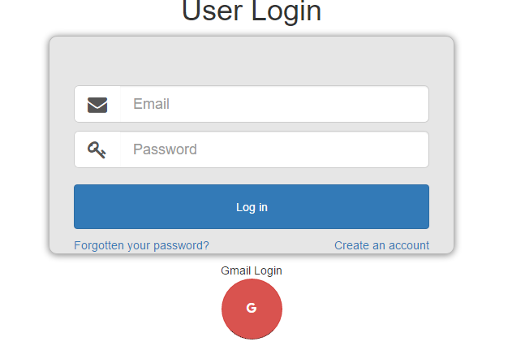

1. **Open Profile Page**

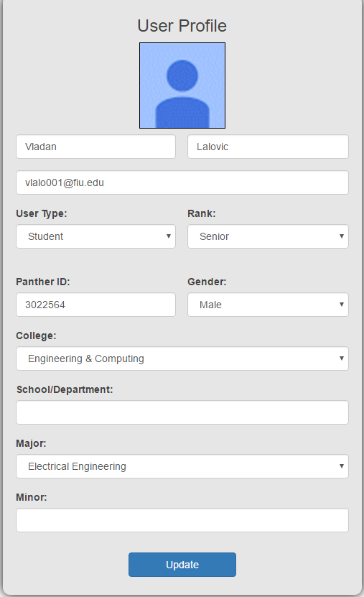

1. **Fill in changes, and press submit.**

